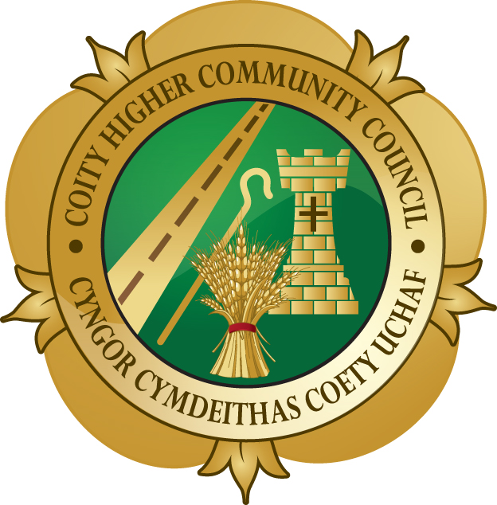
COITY HIGHER COMMUNITY COUNCIL

MINUTES OF A MEETING OF THE COUNCIL HELD AT THE COMMUNITY CENTRE, HEOL WEST PLAS, LITCHARD CROSS, BRIDGEND ON THURSDAY, 12TH FEBRUARY AT 7.00 PM

Present: Mr Hopkin Thomas (Chair)

Councillors: Mr A Clemett
Mrs A Davies
Mrs E Dodd
Ms C Jones
Mr B Tiltman
Mr R Young

Also Present: Mrs A C Harris, Clerk & RFO
Mr P J Ley, Assistant Clerk & FO
Mr & Mrs Ian Coles (for Community Presentation
the first 15 minutes of the meeting)
Mr Andrew Hobbs & Mr Zak Shell, BCBC (part of
the meeting)

Apologies: Councillors June Brett, Maureen Lewis, Alan Wathan and Marilyn Williams

97 DECLARATIONS OF INTEREST

The following interests were declared:

Councillor | Item | Minute | Interest | Speak/Vote
Mrs E Dodd | BCBC/Development Control & Allotment Gardens | 99 | Member BCBC and wife of Allotment Garden tenant | No/No
Ms C Jones | BCBC/Development Control | 101 | Member BCBC | No/No
Mr B Tiltman | Allotment Gardens | 99 | Tenant | No/No
Mr R Young | BCBC – Development Control | 101 | Member BCBC | No/No

98 MEMBERS’ REPORTS

RESOLVED:

One Member had attended the Countryside Access Forum meeting where, amongst other items, a reduction in Rights of Way staff was discussed and the effect this would have on the maintenance of footpaths.

99 ALLOTMENT GARDENS

RESOLVED:

That the report, and addendum report, of the Clerk be accepted.

1.Pest Control System

That the tenant who raised the request for a pest control system be contacted and advised that after writing to every tenant, it was agreed that there was no need for a system as only one tenant had made a request.

2.Vacant Plots

That the action of the Clerk be noted.

100 BUDGET MONITORING & ACCOUNTS

RESOLVED:

That the report, and addendum report, of the Clerk be accepted.

1.Payment of Cheques

That authority be given for payment of the cheques listed on the Clerk’s report and addendum report.

2.Budget Monitoring, Accounts & Budgets

That the report of the Clerk for Period 9, including the balances and budget for 2014/2015 be accepted.

3.Financial Assistance

That the requests for donations from The Noah’s Ark Children’s Hospital Charity, The Teenage Cancer Trust and The Pit Pony Sanctuary & Fforest Uchaf Horse and Pony Centre be deferred to the March 2015 meeting.

That a donation of £20 be made to the Royal Welsh Comrades Association Bridgend Branch toward the cost of a new Royal Welsh Standard.

4.BCBC Budget Workshop for Town and Community Councils

Mr Andrew Hobbs and Mr Zak Shell were welcomed to the meeting; they updated Members on BCBC’s Budget Workshop for Town and Community Council and answered any questions raised by Members.

5.Fund for Town and Community Councils Projects

It was agreed that the widening of the island in the centre of the road on Litchard Hill to provide a safer pedestrian refuge would be put forward for this grant. The bus shelter at Litchard Cross would be financed out of the community council’s budget.

101 DEVELOPMENT CONTROL & PLANNING

RESOLVED:

That the Clerk’s report, and addendum report be accepted.

1.Application Notices Received:

No observations were offered on any of the applications or the withdrawal submitted.

102 ENVIRONMENT

RESOLVED:

That the Clerk’s report, and addendum report, be accepted.

1.Footpath Flyer

That one long and one short walk be included on the flyer. The setting up of a working group to take this project forward be on hold until the diversion of footpath 46 be reviewed.

2.Footpath 46

That the action of the Clerk be noted.

3.Footpath 17

That the action of the Clerk be noted. It was agreed that the Clerk contact the Consortium representative again as the signs erected at the top half of the footpath were unclear.

4.Hanging Baskets for 2015

That the action of the Clerk be noted. The Clerk was given authority to go ahead and order the additional baskets for outside the two Parc Derwen entrances.

5.Bin at Coity Playing Field

That the action of the Clerk be noted.

6.Flowerbed Coity Road

That the completion date from the landscaper be noted.

7.Noticeboards

That the erection of the two new boards be noted. The Parc Derwen Community Group request for a noticeboard on the estate was noted, but it was felt that a decision on where to place a board should be deferred until the estate was finished.

8.BT Services at Parc Derwen

That the report of the Clerk be noted. It was agreed that no further action could be taken on this matter. The Clerk would write to the resident regarding this decision.

103 WELLBEING

RESOLVED:

That the report of the Clerk be accepted.

1.Community Council Additional Agenda Item – Update re. Bus Shelter Litchard Hill

That as one objection had been raised to this shelter, Councillor Young, the Chair and the Clerk would meet with the resident to try and progress this matter.

2.Annual Community Award

Recipient Mr Ian Coles and his wife, Karen, attended the meeting for a short presentation of a large engraved shield to Mr Coles and a floral bouquet to his wife. Photographs were taken to be uploaded onto the website.

3.Website

That the action of the Clerk be noted.

4.Prevention and Wellbeing Agenda, BCBC

That Annette Parkes, the new Principal Development Officer Prevention and Wellbeing Strategy at BCBC would attend the start of the next meeting to talk to Members about her work and to answer any questions.

104 GOVERNMENT & OUTSIDE BODIES

RESOLVED:

That the report, and addendum report, of the Clerk be accepted.

1.Forwarded via E-mail this Month

That the report, and addendum report, of the Clerk be accepted.

2.Crime Statistics

That the Clerk’s report and the statistics for December 2014 be accepted.

3.One Voice Wales

That the report, and addendum report, of the Clerk be accepted.

105 HIGHWAYS & TRANSPORTATION

RESOLVED:

That the report of the Clerk be accepted.

1.Temporary Road Closure – Hendre Road and Hendre Road Lane, Pencoed

That the temporary closure notice be noted.

106 INVITATIONS, NOTICES & PUBLICATIONS

RESOLVED:

That the invitations, notices and publications listed in the Clerk’s reports, be accepted.

The Chair and Consort are unable to attend the Dunraven Welsh Young Singer 2015 final.
Mr Alun Clemett and guest would attend to represent the Community Council.

107 EXCLUSION OF PUBLIC

RESOLVED:

That the public be excluded from the remainder of the meeting under the provisions of
The Public Bodies (Admission to Meetings) Act 1960, because it would not be in the public interest to discuss the information contained within the following items of business.

108 SALARIES, EXPENSES AND ASSOCIATED PAYMENTS

RESOLVED:

That the report of the Assistant Clerk be noted and accepted, and the January
salaries and associated payments to the Clerk & RFO, and Assistant Clerk & FO, be agreed and authorised.

